

Department of Electronics & Communication Engineering

Report on Embedded Linux Project “Intelligent Lighting System Using LDR and Raspberry Pi”
Submitted by:

Sl. No. | Name | SRN
1 | Jamuna Pulapatli | 02FE22BEC032
2 | Priyanka Budihal | 02FE22BEC054
3 | Rutuja | 02FE22BEC072
4 | Saniya | 02FE22BEC081
5 | Santoshi Uppin | 02FE22BEC085

Under the guidance of:

Prof. Anita Shirol Prof. Tejaswini Bargukar

KLE Technological University, Dr. M. S. Sheshgiri Campus, Belagavi

Academic Year 2025–26

Contents
- Introduction 2
- Aim 2
- Objectives 2
- Hardware Components 3
- Software components 4
- System Architecture 5
- Working Principle 6
- Program Code 7
- Results 8
- Applications 9
- Future Enhancement 9
- Conclusion 9

Introduction
In modern buildings and urban environments, energy efficiency is a primary concern. Traditional lighting systems consume electricity regardless of the availability of natural light, leading to unnecessary power wastage. To overcome this issue, an Intelligent Lighting System using LDR (Light Dependent Resistor) and Raspberry Pi is proposed. The system automatically adjusts the lighting intensity or switches lights on/off based on the surrounding light conditions. This project utilizes the power of Embedded Linux and Python programming to create an energy-efficient, automated lighting control system.
Using this combination, the system can automatically switch ON or OFF lights based on the environmental lighting conditions.
The integration of Embedded Linux provides a stable and flexible platform for controlling hardware devices while offering the computational capability for complex decision-making, networking, and future scalability into Internet of Things (IoT) applications.
This project demonstrates how embedded systems can be effectively used in energy-efficient automation by merging hardware sensing with software control, thus forming an intelligent ecosystem for modern smart cities and homes

Aim
The aim of this project is to design and implement an intelligent lighting control system using LDR and Raspberry Pi under an Embedded Linux environment to minimize power wastage by automating light operation according to ambient brightness levels.

Objectives
The specific objectives of this project are:
- To develop an automated lighting control system that functions based on ambient light intensity.
- To interface an LDR sensor with the Raspberry Pi GPIO for real-time light detection.
- To utilize Python programming for logical control of light switching.
- To demonstrate the effectiveness of an embedded Linux-based platform for real-world applications.
- To reduce energy wastage by automating lighting systems.
- To provide a scalable base that can be expanded for IoT-based smart home applications.
- To analyze the system’s performance in terms of response time, accuracy, and energy savings.
- To enhance system reliability by ensuring fault-tolerant software design and safe shutdown routines using GPIO cleanup mechanisms.
- To provide user feedback via console output or GUI indicating the system’s current status (Light ON/OFF).
- To promote environmental sustainability by encouraging the use of smart automation in daily energy consumption.
4. Hardware Components

Component | Specification | Function
Raspberry Pi (Model 3B/4) | Quad-core ARM Cortex-A53/A72 CPU, 1–4 GB RAM, 40 GPIO pins, microSD storage, Ethernet/Wi-Fi connectivity | Acts as the main controller running Embedded Linux (Raspberry Pi OS). It processes sensor data from the LDR, executes Python-based control logic, and controls the output (LED or relay).
Light Dependent Resistor (LDR) | Photoresistor; resistance varies inversely with light intensity (typically 1 kΩ – 100 kΩ) | Senses the ambient light level. Its resistance decreases as light intensity increases, providing input for light detection.
Resistors (Fixed) | 10 kΩ (typical) ±5% tolerance | Used in voltage divider circuits with the LDR to generate a measurable voltage signal for the Raspberry Pi GPIO input.
LED (Indicator Light) | 5 mm red/green LED, forward voltage ~2 V, forward current ~20 mA | Acts as the output indicator. Turns ON in dark conditions and OFF in bright light, demonstrating automatic lighting control.
Relay Module (Optional) | 5 V single-channel relay, opto-isolated control input | Used when controlling high-power AC lights instead of an LED. Provides electrical isolation between low-voltage control and high-voltage load.
Breadboard and Jumper Wires | Solderless breadboard, male–female jumper wires | Provides easy and flexible circuit connections between Raspberry Pi, sensors, and output devices for prototyping and testing.
Power Supply Unit | 5 V / 2.5 A regulated adapter (for Raspberry Pi); optional 5–12 V (for relay or external modules) | Provides stable DC power to the Raspberry Pi and other peripherals ensuring reliable operation.
MicroSD Card | 16 GB or higher, Class 10 recommended | Used to store and run the Raspbian (Embedded Linux) operating system, Python scripts, and system configuration files.
Monitor, Keyboard, and Mouse (Setup Components) | HDMI display, USB keyboard and mouse | Used initially for OS installation, configuration, and debugging of the Python code before enabling SSH/VNC remote access.
Optional Sensors (for Future Enhancement) | PIR sensor / Ultrasonic sensor / LDR array | Can be integrated for motion-based lighting control or multi-point brightness sensing to improve automation and energy efficiency.

Software components
Software | Version | Purpose
Raspberry Pi OS Lite (Embedded Linux) | Latest stable release (Debian-based) | Serves as the primary operating system for the Raspberry Pi. Provides a lightweight and stable Linux environment optimized for headless operation, command-line control, and execution of automation scripts.
Python 3.x | Compatible with Raspbian OS | Used for developing the intelligent lighting control logic. Offers extensive library support for hardware interfacing, GPIO manipulation, timing control, and data processing.
RPi.GPIO Library | Compatible with Python 3.x | Enables direct access to Raspberry Pi GPIO pins. Used to read input from the LDR sensor and control the LED or relay output pins.
time Library (Python Standard Library) | Built-in with Python 3.x | Used to manage delays and timing loops in the automation process, ensuring smooth transitions and periodic sensor checking.
Thonny IDE / Terminal | Latest version (pre-installed on Raspbian) | Provides an integrated development environment for writing, running, and debugging Python code directly on the Raspberry Pi.
SSH (Secure Shell) | OpenSSH (pre-installed on Raspberry Pi OS) | Allows secure remote login and execution of programs from another system. Facilitates headless operation and debugging without a display.
VNC Viewer (Optional) | Any latest compatible version | Enables remote graphical access to the Raspberry Pi desktop for easier system monitoring and code updates.
systemd Service Manager | Built-in Linux utility | Used to configure the Python automation script as a background service that runs automatically on boot and logs activity.
spidev Library (Optional) | Compatible with Python 3.x | Provides SPI communication interface for integrating analog-to-digital converters (if used in expanded versions of the project).
nano / vim Editor | Pre-installed Linux text editors | Used for editing configuration files, startup scripts, and code directly from the command line environment.

5.System Architecture

Architecture Overview
The architecture is divided into hardware and software layers that work together to perform intelligent lighting control based on ambient brightness.
The hardware layer includes the Raspberry Pi, LDR sensor, LED or relay module, and power supply components.
The software layer is built on Embedded Linux (Raspberry Pi OS Lite), which runs a Python program responsible for reading sensor data and controlling the light output in real time.
The system continuously monitors light intensity and automatically turns the lights on or off depending on the surrounding illumination.
It also supports remote monitoring and debugging through SSH or VNC, enabling control and configuration from another device.

System Components and Flow
- Input Stage
The Light Dependent Resistor (LDR) detects the surrounding light intensity. Its resistance varies with the brightness level. The voltage generated by the LDR and resistor network is provided to the Raspberry Pi GPIO pin, serving as a digital input for the system.
- Processing Stage
The Raspberry Pi acts as the central controller. It runs the Raspberry Pi OS Lite (Embedded Linux) and executes a Python program that continuously reads the LDR input signal. Based on predefined threshold values, the program decides whether the environment is bright or dark.
- Decision Logic
The control logic written in Python evaluates the LDR input and determines the lighting condition:
  - When the LDR detects low light (high resistance), the LED or relay output is activated.
  - When sufficient light is detected (low resistance), the LED or relay output is deactivated.
- Output Control Stage
The Raspberry Pi generates digital control signals through its GPIO pins. These signals drive either a low-power LED (for testing) or a relay module (for controlling higher power lamps). The relay isolates the low-voltage control circuit from the high-voltage lighting circuit.
- Power Supply Stage
The entire system is powered by a regulated 5V DC adapter connected to the Raspberry Pi. The relay or LED receives power either from the same supply or from a separate DC source to ensure stable operation and electrical isolation.
- Software Control and Automation
The control logic is implemented in Python using standard libraries such as RPi.GPIO and time. The Python program can be configured as a background service using systemd, which ensures:
  - Automatic execution on system startup
  - Continuous operation without manual intervention
  - Logging of system activity for debugging
- Remote Access and Monitoring
Using SSH or VNC Viewer, users can remotely access the Raspberry Pi from another computer or mobile device. This allows them to monitor the LDR sensor readings, check the lighting status, and make adjustments to the control script as needed.

Key Features
- Automatic control of lighting based on ambient light intensity.
- Real-time response to changes in environmental brightness.
- Improved energy efficiency by switching lights on only when required.
- Modular and scalable architecture suitable for smart home and industrial use.
- Remote access capability through SSH or VNC for monitoring and debugging.
- Reliable startup and background operation using systemd service management.
- Low-cost implementation using open-source hardware and software components.

6.Working Principle
The working principle of the Intelligent Lighting System using Embedded Linux on Raspberry Pi is based on real-time sensing and automated control logic implemented through both hardware and software interaction. The system continuously monitors the ambient light level using an LDR sensor and automatically controls a connected light (LED or relay) according to the detected brightness. This ensures efficient energy usage and reduces manual effort in lighting control.

Step-by-Step Operation
- Light Detection:
The Light Dependent Resistor (LDR) senses the surrounding light intensity. Its resistance changes inversely with light — resistance decreases when the environment is bright and increases when it becomes dark.
- Signal Conditioning:
The LDR is connected in a voltage divider configuration with a fixed resistor. The varying resistance of the LDR produces a corresponding voltage change, which is read by one of the Raspberry Pi’s GPIO pins as a digital input signal.
- Data Processing:
The Raspberry Pi, running Embedded Linux (Raspberry Pi OS Lite), executes a Python-based control program. The program reads the LDR input signal at regular intervals and compares it against a predefined threshold value to determine whether the surroundings are bright or dark.
- Decision Making:
The Python program uses conditional logic to decide when to turn the light ON or OFF.
  - If the detected light level is below the threshold (dark environment), the system activates the LED or relay output.
  - If the detected light level is above the threshold (bright environment), the system deactivates the LED or relay output.
- Output Control:
Based on the decision, the Raspberry Pi sends a digital HIGH or LOW signal through its GPIO pin.
  - A HIGH signal turns on the LED or activates the relay to switch on the connected light.
  - A LOW signal turns off the LED or deactivates the relay to switch off the light.
- Real-Time Operation:
The program runs in a continuous loop with a short delay (e.g., 0.5 seconds) between readings. This allows the system to respond almost instantly to any change in ambient light conditions, maintaining proper illumination at all times.
- Power Management:
The Raspberry Pi and connected components receive stable power from a 5V regulated adapter. The circuit is designed to ensure safe operation and prevent voltage fluctuations that could affect sensor readings or GPIO signals.
- System Automation and Reliability:
The control program can be configured to run automatically on startup using the Linux systemd service. This ensures that the system operates continuously, even after a reboot, without requiring manual execution of the code.
- Remote Monitoring and Debugging:
Through SSH or VNC connections, users can remotely monitor the system, check status messages printed by the Python program, and make modifications to the control logic as needed.
- Scalability:
The design is modular and can be expanded to include additional sensors such as PIR motion sensors or light intensity arrays. It can also be upgraded for IoT applications to allow remote lighting control through a web interface or mobile app.

Program Code

import RPi.GPIO as GPIO
import time

# Pin setup
LDR_PIN = 18 # LDR Node A connected to GPIO18
LED_PIN = 17 # LED connected to GPIO17

GPIO.setmode(GPIO.BCM)
GPIO.setup(LDR_PIN, GPIO.IN)
GPIO.setup(LED_PIN, GPIO.OUT)

try:
while True:
if GPIO.input(LDR_PIN) == GPIO.LOW:
# DARK → LED ON
GPIO.output(LED_PIN, GPIO.HIGH)
print("Dark detected → LED ON")
else:
# LIGHT → LED OFF
GPIO.output(LED_PIN, GPIO.LOW)
print("Light detected → LED OFF")
time.sleep(0.5)

except KeyboardInterrupt:
GPIO.cleanup()

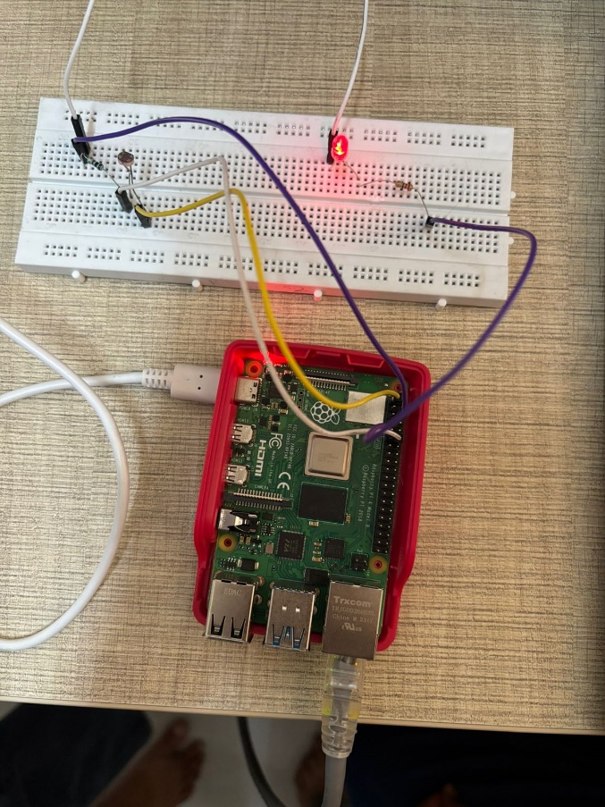
Results
The intelligent lighting system successfully detected changes in ambient light intensity using the LDR sensor.
• Real-time control was achieved as the LED or relay responded instantly to variations in light levels.
• The Raspberry Pi processed input data efficiently, and the Python program executed continuously without interruptions.
• The LED turned ON automatically when the environment became dark and turned OFF when adequate natural light was available.
• The control logic worked reliably across different light conditions, demonstrating accurate threshold-based switching.
• The system operated as a background service using systemd, ensuring automatic startup on every boot and uninterrupted operation.
• Remote monitoring through SSH and VNC allowed easy observation of system performance and debugging of the Python code.
• Power supply remained stable during continuous operation, and there were no issues of overheating or voltage drop.
• The LDR sensor provided consistent readings, validating the reliability of the sensing mechanism.
• Overall, the system exhibited robust performance, low latency, and high reliability, confirming the effective integration of hardware and software under the Embedded Linux environment.

Applications
• Home automation systems for automatic indoor lighting control based on the availability of natural light.
• Street lighting systems that turn on automatically at dusk and turn off at dawn to reduce power wastage.
• Office and commercial building lighting management to maintain optimal brightness and reduce electricity bills.
• Smart classroom or laboratory environments where automatic lighting ensures proper illumination and convenience.
• Industrial lighting systems for warehouses and production areas to improve energy efficiency and safety.
• Smart city infrastructure projects where large-scale automated lighting helps reduce urban energy consumption.

Future Enhancement
The system can be enhanced by integrating Internet of Things (IoT) capabilities, allowing remote monitoring and control of lighting through mobile or web-based applications.
• Machine learning algorithms can be implemented to enable adaptive brightness control based on time of day, weather conditions, and occupancy patterns.
• Additional sensors such as motion detectors (PIR), temperature sensors, or ultrasonic modules can be included to improve automation and energy efficiency.
• Data logging and cloud integration can be added to record lighting usage statistics, enabling predictive maintenance and performance analysis.
• A mobile app interface can be developed for user-friendly configuration, real-time monitoring, and manual override of the automated lighting system.
• Solar power can be integrated as an energy source to make the system self-sustaining and environmentally friendly.

Conclusion
The Intelligent Lighting System using LDR and Raspberry Pi successfully demonstrates how embedded systems can be applied to achieve automation and energy efficiency in everyday life. The project integrates hardware sensing with software control under an Embedded Linux environment, providing a reliable and cost-effective solution for automatic lighting control.

